**Lab 1 – Fundamentals Review**

This lab does not introduce any new material, but instead focuses on testing your understanding of, and ability to use, the techniques and concepts discussed in Programming Fundamentals I. Specifically, it emphasizes the use of multi-dimensional arrays and functions, including the passing of arrays as arguments. If you are uncertain in your understanding of these concepts, that’s okay – this lab highlights some of the concepts that many students struggle with, and it should serve to let you know what you will want to brush up on as we get into new content.

**Sample Program**

The included sample program, TicTacToe.cpp, uses a two-dimensional array to simulate the board for a two-player game of tic-tac-toe. The array for the board is declared and initialized in the main function, where it will be used in the main game loop, but is passed as an argument to separate functions controlling the display of the game board, and the lengthy process of checking for a winner after each player’s turn.

**Your Program**

For your lab, you will create a program to display a yearly calendar, using a three-dimensional array to represent the calendar itself. Your array should use a standard size of 6 by 7 by 12, representing weeks, days, and months, respectively.

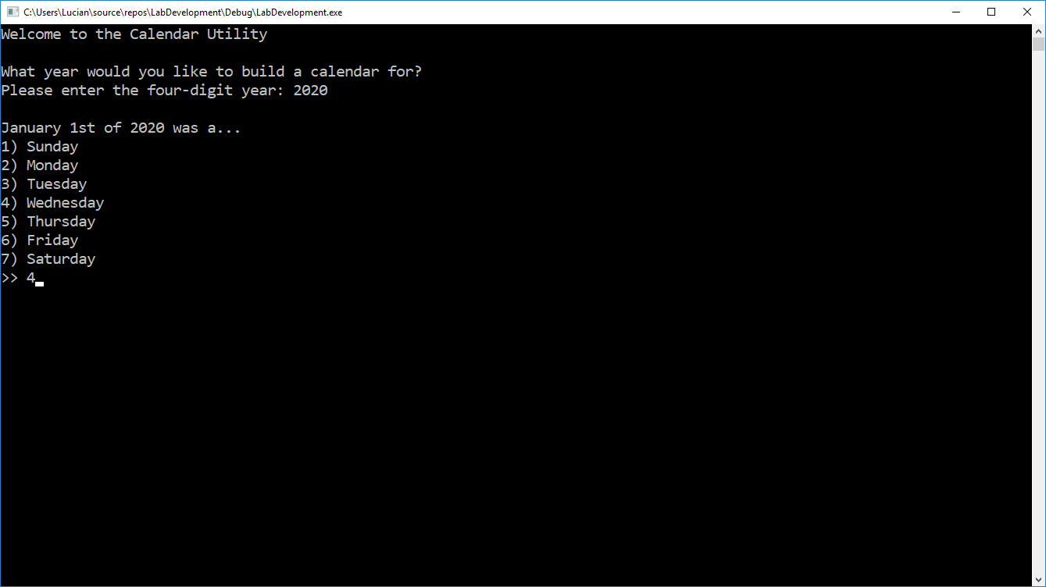Your program should begin by calling an initialization function which asks the user to enter the four-digit calendar year (e.g. 2020), and then prompts them to select what day January 1st of that year was (e.g. Wednesday for 2020). This can be seen demonstrated in the screenshot on the right.

With this information, you should then initialize the calendar. The day of January 1st will let you know where you should start numbering from - the first few locations may be left blank if the year did not begin on a Sunday. The other thing you must consider is whether or not the year is a leap year, which will determine whether February has 28 or 29 days. To check if it is a leap year or not, remember that a leap year is any that:

* Is evenly divisible by 4
* Is NOT evenly divisible by 100, unless…
* It is also evenly divisible by 400.

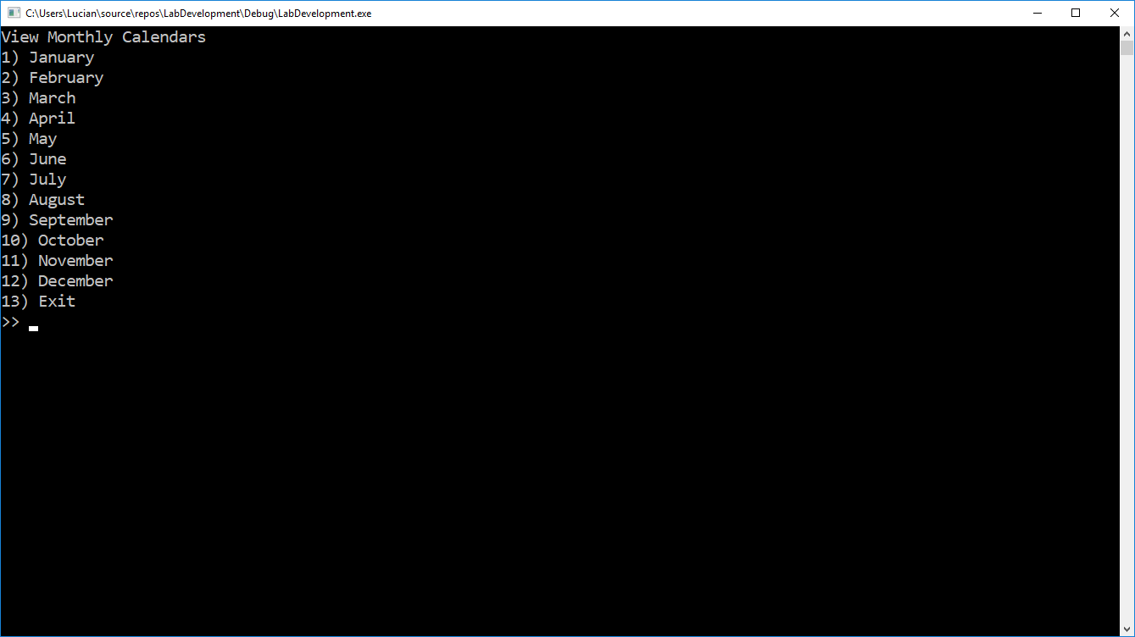After verifying whether the year is a leap year or not, and properly initializing the calendar, the main program loop (in the main function) should prompt the user to view the calendar for any given month. This menu can be seen in the screenshot on the right.

Selecting any given month will call a separate function to display that month’s calendar in a nicely formatted manner, as can be seen for January and February of 2020 in the screenshots below.

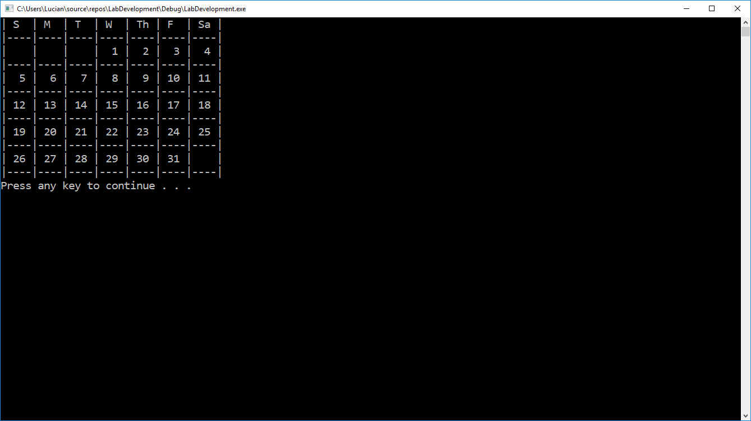 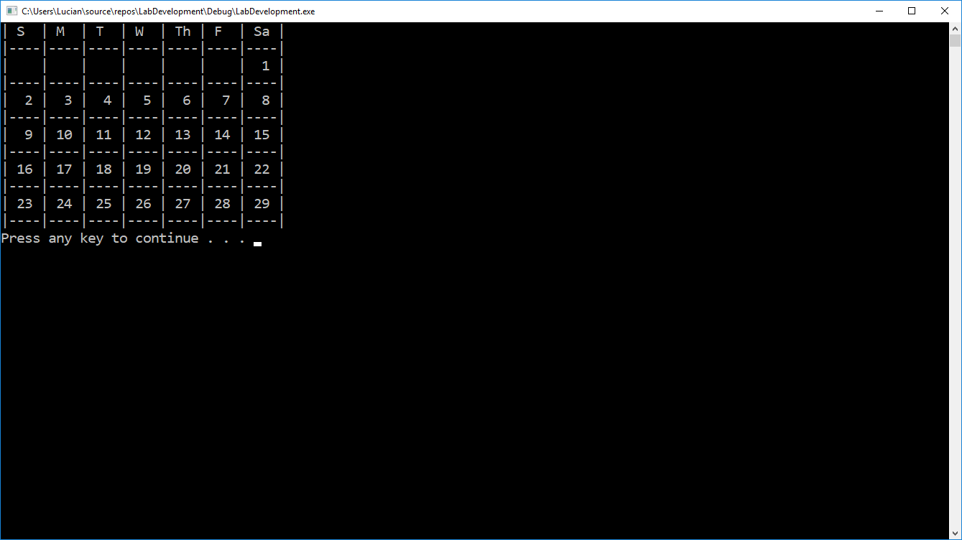

When you are done, submit the completed .cpp file through the Blackboard submission tool. Please name your source file [FirstInitial][LastName]_Lab1.cpp, substituting your own name. For instance, my submission would be LSilcox_Lab1.cpp.